Ciclo de Palestras 2018
A different approach for understanding processes in biology and environmental science: Novel analytical strategies
Prof. Joerg Feldmann, PhD, FRSC, FRSE
Chair in Environmental Analytical Chemistry at the University of Aberdeen, Scotland, and Director of TESLA (https://www.abdn.ac.uk/ncs/departments/chemistry/trace-element-speciation-laboratory-111.php). 2015 European Award for plasma Spectrochemistry, 2016 RSC Medal and Interdisciplinary Prize, 2018 elected fellow of the Royal Society of Edinburgh.
Local: Auditório do CEPETRO (Prédio 67 A)
Hora e Data: às 15:30 h, segunda-feira, 04 de junho de 2018

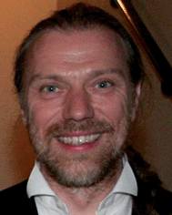
Abstract:
This talk will demonstrate that novel analytical approaches need to be taken in order to answer scientific questions in biology and environmental sciences. It will illustrate using a series of case studies that we need sometimes to rethink our viewpoints and develop novel analytical methods which will assist to answer complex questions. It will encompass cases which cannot only be solved by analytical chemists but need the collaborative effort from other scientist from other disciplines to maximise impact. It will embraces the work of not only interdisciplinary but multidisciplinary work.

