Section

Main title

Translated title
Authorship 1^{I}, Authorship 2^{II}, Authorship 3^{III} [Não preencher os itens em amarelo]
^{I} Institution, Departament [if there is], City, State [initials], Brazil
^{II} Institution, Departament [if there is], City, State [initials], Brazil
^{III} Institution, Departament [if there is], City, State [initials], Brazil

ABSTRACT

For the Abstract title: align to the left, Opens Sans 10 font, all caps, bold, single-space 1,0. This space is for the abstract of the article. The abstract must contain a maximum of 15 lines, written in Open Sans 10 font, justified. The abstract must contain a maximum of 15 lines, written in Open Sans 10 font, justified. The abstract must contain a maximum of 15 lines, written in Open Sans 10 font, justified. The abstract must contain a maximum of 15 lines, written in Open Sans 10 font, justified. The abstract must contain a maximum of 15 lines, written in Open Sans 10 font, justified. The abstract must contain a maximum of 15 lines, written in Open Sans 10 font, justified. Important: The text of the abstract present in the Word document must match the abstract submitted to the electronic system of the Magazine. Important: The text of the abstract present in the Word document must match the abstract submitted to the electronic system of the Magazine.

Keywords: Term1; Term2; Term3

RESUMO

Second language abstract here. Second language abstract here. Second language abstract here. Second language abstract here. Second language abstract here. Second language abstract here. Second language abstract here. Second language abstract here. Second language abstract here. Second language abstract here. Second language abstract here. Second language abstract here. Second language abstract here. Second language abstract here. Second language abstract here. Second language abstract here. Second language abstract here. Important: The text of the abstract in the second language present in the Word document must match the abstract submitted to the electronic system of the Magazine. Important: The text of the abstract in the second language present in the Word document must match the abstract submitted to the electronic system of the Magazine.

Palavras-chave: Term1; Term2; Term3 (avoid automatic translation)

1 INTRODUction Or Title of main section [if there is]
Attention: we highly recommend that the authors use the present template and all its fonts formats, margins, spacing and other rules. Therefore, the authors simply need to replace the content of each segment, starting with the title, abstract, keyword etc.
In the case of this main section (its main title) specifically: Section title aligned to the left, Opens Sans 10 font, all caps, bold, 1,5 spacing. Section content in Opens Sans 12 font, 1,5 spacing and paragraphs with indentation of 1,25 cm.
The introduction must contain elements that are crucial to fully comprehend the text. It is suggested that the authors begin the article with a brief contextualization of the matter and then present the PROBLEM that was studied and will be elucidated. It is also recommended that the OBJECTIVES are precisely explained. At the end of the introduction, it is advised that a concise overall structure of the article is presented to allow the reader to understand how the matter will be approached from that point on.
Footnotes are organized with Arabic numbers (1, 2, 3…), aligned to the left, in Opens Sans 10 font, with capital letters in the first one of the sentence or words that the language requires.

1.1 Subsection title [if there is]
Subsection title in Open Sans 12 font, aligned to the left, spacing of 1,5 cm, with capital letters in the first one of the sentence or words that the language requires (e.g., proper nouns). Subsection content in Open Sans 12 font, aligned to the left, spacing of 1,5 cm and paragraphs with indentation of 1,25 cm.

1.1.1 Example of section under subsection [if there is]
Title section under a subsction in Open Sans 12 font, aligned to the left, spacing as the model, with capital letters in the first one of the sentence or words that the language requires (e.g., proper nouns).
Attention: follow strictly all the norms of the magazine when quoting and referencing. Bellow there is an example of a long quotation (more than 3 lines). In cases of short quotation (3 lines or less), the authors simply need to insert it with quotation marks in the body of the text. Keep in mind that REMOA utilizes a “Author, date” systems for quotations
Long quotation (more than 3 lines) in Open Sans 10 font, single-space (1,0), with an indentation of 4 cm, justified alignment. Long quotation (more than 3 lines) in Open Sans 10 font, single-space (1,0), with an indentation of 4 cm, justified alignment. Long quotation (more than 3 lines) in Open Sans 10 font, single-space (1,0), with an indentation of 4 cm, justified alignment. Long quotation (more than 3 lines) in Open Sans 10 font, single-space (1,0), with an indentation of 4 cm, justified alignment.
Continuation of the text with the content of the section in Open Sans 12 font, with 1,5 spacing and a paragraph indentation 1,25 cm. Continuation of the text with the content of the section in Open Sans 12 font, with 1,5 spacing and a paragraph indentation 1,25 cm. Continuation of the text with the content of the section in Open Sans 12 font, with 1,5 spacing and a paragraph indentation 1,25 cm. Continuation of the text with the content of the section in Open Sans 12 font, with 1,5 spacing and a paragraph indentation 1,25 cm.
1.1.1.1 Example of one more section
If the work requires another subsection this model must be used. The titles of the sections and subsections must follow a logic order and be presented according this template.

2 New section
Text with the content of the section in Open Sans 12 font, with 1,5 spacing and a paragraph indentation 1,25 cm. The text with the content of the section in Open Sans 12 font, with 1,5 spacing and a paragraph indentation 1,25 cm.
For “direct quotations, with up to three lines, use quotation marks, referencing the authorship, year of the work and number of the page from where it was extracted” (AUTHORSIP, year, page number).
Indicate with brackets if there is the need to suppress any passage in the quote [...]. The authorship, year of the work and number of the page from where it was extracted, must always be referenced. All quotes in a foreign language must be translated to English if the translation does not affect the meaning of the original sentence. (AUTHORSHIP, year, page number)
Quotes must be labeled in the body of the text with the last names, year of publishing and for direct quotations, the number of the page.
For mentions of the authorship in a sentence only the first letter must be capitalized and when it is done between parentheses all letters should be capitalized, as shown in the examples bellow:
According to Corrêa (1997, p. 152), "O espaço enquanto objetivação geográfica do estudo da cidade apresenta várias facetas que permitem que seja estudado de modo multivariado".
OR:
"O espaço enquanto objetivação geográfica do estudo da cidade apresenta várias facetas que permitem que seja estudado de modo multivariado" (CORRÊA, 1997, p.152)
The articles can only reference figures (photographs, maps, images, or graphs), charts and tables. Every figure, chart or table that is used must be referenced in the body of the text (e.g., figure 1, chart 1) before being shown, as the following example where the figure 1 title is brief and complete.
Figure 1 – Brief and complete title
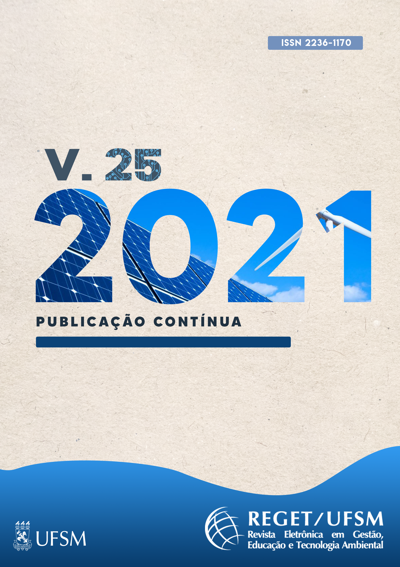
Source: Authors (year)
Caption: The legends must be under the source.
Note: In cases that the photo was taken by the authors indicate Source: Author’s/ Authors’ private collection (month, year)
Important: what differs the chart to the table is that visually the chart is closed in the sides where the table is open. Tables and charts are better disposed in a single page so whenever possible arrange the text to follow this item. When it is not possible the text can suffer adjustments in the layout editing, so the title is associated above the figure, chart, or table. See chart 1.
Chart 1 – The charts titles must be above it
Column 1 | Column 2 | Column 3 | Column 4
Line 1 | Value 1 | Value 2 | Value 3
Line 2 | Value 4 | Value 5 | Value 6
Line 3 | Value 7 | Value 8 | Value 9
Line 4 | Value 10 | Value 11 | Value 12
Line 5 | Value 13 | Value 14 | Value 15
Source: the sources of the charts must be under it. When it discloses data formulated in the research, indicate: Organized by the authors.

Tabela 1 – The table titles must be above it
Column 1 | Column 2 | Column 3 | Column 4
Line 1 | Value 1 | Value 2 | Value 3
Line 2 | Value 4 | Value 5 | Value 6
Line 3 | Value 7 | Value 8 | Value 9
Line 4 | Value 10 | Value 11 | Value 12
Line 5 | Value 13 | Value 14 | Value 15
Source: the sources of the tables must be under it. When reproduced entirely, indicate Source: Authorship (year)
Equations are inserted in the body of the text, being numbered in the right side within parenthesis, as shown below:
$$y=ax+b$$ | (1)
where:
Open Sans 10;
Single-space;
with the topics divided with semicolon.

3 ConCLusions
Text with the content of the section in Open Sans 12 font, with 1,5 spacing and a paragraph indentation 1,25 cm. The text with the content of the section in Open Sans 12 font, with 1,5 spacing and a paragraph indentation 1,25 cm.

acknowledgements [IF there are]
Write here your acknowledgements.

Referências
As referências devem ser colocadas em ordem alfabética, com fonte Open Sans tamanho 11, espaçamento simples, sem recuo de primeira linha, espaçamento de 12 pt depois de cada uma, obedecendo os seguintes critérios:
- Livro: SOBRENOME do/a autor(a) da obra, Prenomes abreviados. Título da obra: subtítulo. Número da edição. Local de Publicação: Editora, ano de publicação. Citam-se todos, separados por ponto e vírgula. Sobrenome inglês precedido de Mac ou Mc permanece na mesma forma. A expressão et al. será utilizada somente no texto para mais de três autores. Nas referências, recomenda-se que a autoria seja citada em sua totalidade, com exceção de um grande número de autores/as.

LEFF, E. Discursos sustentáveis. São Paulo: Cortez, 2010.
Mac LAUGHLIN, J. Reimagining the nation-state. The contested terrains of nation-building. London (Inglaterra): Pluto Press, 2001.
MATEO RODRIGUEZ, J. M. et al. Estructura geográfica ambiental y sostenibilidad de las cuencas hidrográficas urbanizadas de Cuba el ejemplo de la cuenca del río Quibú, provincia Ciudad de La Habana: resultados del Proyecto Caesar. La Habana (Cuba): Editorial Universitaria, 2008.
NOVO, M. La educación ambiental. Bases éticas, conceptuales y metodológicas. 2. ed. Madrid (Espanha): Editorial Universitas, 2003.
- Capítulo de livro: SOBRENOME, Prenomes abreviados. Título do capítulo: subtítulo. In: SOBRENOME, Prenomes abreviados. (org. OU ed.) Título da obra: subtítulo. Número da edição. Local de Publicação: Editora, ano de publicação. Página inicial e final do capítulo. Exemplos:
ROSENDAHL, Z. Território e territorialidade: uma perspectiva geográfica para o estudo da religião. In: CORRÊA, R. L.; ROSENDAHL, Z. (Org.). Geografia: temas sobre cultura e espaço. Rio de Janeiro: Editora UERJ, 2005. p. 191-226.
LUZZI, D. A “ambientalização” da educação formal. Um diálogo aberto na complexidade do campo educativo. In: LEFF, E. (Org.). A complexidade ambiental. São Paulo: Cortez, 2003. p. 178-216.
- Artigo de periódico: SOBRENOME DO(A) AUTOR(A) DO ARTIGO, Prenomes abreviados. Título do artigo: subtítulo. Título do Periódico, cidade de publicação, número do volume, número do fascículo, páginas inicial e final do artigo, mês e ano. Exemplos:
BRANDÃO, P. R. B. Devotos, sábios e viajantes: os geógrafos do mundo islâmico medieval. Geog Ens Pesq, Santa Maria, e3, ago. 2018. Disponível em: https://periodicos.ufsm.br/geografia/article/view/23355. Acesso em: 27 jan. 2020. DOI 10.5902/2236499423355.
TRENTIN, R; SANTOS, L. J. C; ROBAINA, L. E. S. Compartimentação geomorfológica da bacia hidrográfica do Rio Itu – Oeste do Rio Grande do Sul – Brasil. Soc. & Nat., Uberlândia, v. 24 n. 1, p.127-142, jan./abr. 2012.
HÖFLING, E. M. Estado e políticas (públicas) sociais. Cadernos Cedes, Campinas, v. 21, n. 55, p. 30-41, novembro/2001. Disponível em: http://www.scielo.br/scielo.php?pid=s0101-32622001000300003&script=sci_arttext. Acesso em: 5 jan. 2016.
- Dissertações e Teses: SOBRENOME, Prenomes abreviados. Título da obra: subtítulo. Ano de defesa. Número de páginas. Categoria (Grau e Área de Concentração) – Instituição, Local, Ano do documento. Exemplos:
ROVANI, F. F. M. Zoneamento de risco climático do cultivo da Nogueira Pecã (Carya illinoinensis) para o Rio Grande do Sul. 2016. 232 p. Tese (Doutorado em Geografia) – Universidade Federal de Santa Maria, Santa Maria, 2016.
JUNCKES, I. J. O sindicalismo novo dos bancários na reestruturação financeira dos anos noventa no Brasil. 2004. 214 p. Tese (Doutorado em Sociologia Política) – Universidade Federal de Santa Catarina, Florianópolis, 2004.
MOURA, G. S. S. Análise do gerenciamento dos resíduos sólidos urbanos do município de Mossoró-RN. 2011. 45 p. Monografia (Bacharel em Ciência e Tecnologia) – UFERSA, Mossoró-RN, 2011.
- Trabalhos apresentados em eventos científicos: SOBRENOME, Prenomes abreviados. Título do trabalho. In: NOME DO EVENTO, Número da edição, Cidade onde se realizou o evento. Anais [...] ou Proceedings [...] ou Resumos [...] Local de publicação: Editora, Ano de publicação. Páginas inicial e final do trabalho. Exemplos:
SILVA, J. M. P. Poder, governo e território em Carajás In: ENCONTRO NACIONAL DA ANPEGE, 6., 2005, Fortaleza. Anais[...] Fortaleza: Expressão Gráfica, 2005. p. 120-121.
LOPES, L. S. O.; SILVA, O. G. Paisagem e patrimônio geomorfológico: revisão conceitual. In: ENCONTRO NACIONAL DA ANPEGE, 11. A diversidade da geografia brasileira: escalas e dimensões da análise e da ação, 2015, Presidente Prudente. Anais[...] Presidente Prudente: ANPEGE, 2015. p. 9355-9365.
Authorship contributions
1 – Author´s full name:
Institucional bond, title
Orcid link and email:
Contribuition:
2 – Author´s full name:
Institucional bond, title
Orcid link and email:
Contribuition:
3 – Exemple of name
Environmental Engineer, Douctor´s in environmental engineering
https://orcid.org/0000-0000-0000-0000 • exempleofemail@ufsm.com
Contribuição: Writing – original draft
How to quote this article

Example of a footnote.

